Design and Analysis of an Audio Amplifier using BJT Transistors(December 2019)

Aaron Tobias, *Student Member, IEEE*, Jaret Varn, *Student Member, IEEE,*

and Joshua Newman, *Student Member, IEEE*

*Abstract*—This page describes an audio amplifier capable of supplying 30mW of power to a 32Ω load corresponding to a *Listen Technologies Corp.* model LA-161 Single Ear Bud is presented. The audio amplifier is broken down into five stages: volume control, bias network, NPN common emitter amplifier with an emitter resistance, PNP emitter follower amplifier, NPN emitter follower amplifier. In order to design this audio amplifier, we were given a certain set of requirements to follow. We were also given a set of output parameters and they are as follows: Quiescent Power Supply Current less than or equal to 200mA, Small-Signal Voltage Gain Deviation less than or equal to .1 dB, 1-dB Output Compression Point greater than or equal to 56.8 dBmV RMS. We were able to simulate our audio amplifier through circuit design software and plot our system for verification of parameters. All five stages and our simulations of our audio amplifier are described.

*Index Terms*—Bipolar transistor circuits, Linear circuits, Operational amplifiers

# INTRODUCTION

T

HE goal of this project was to design an audio amplifier circuit capable of supplying 30mW of power to a 32Ω load which is to represent a *Listen Technologies Corp.* model LA-161 Single Ear Bud. The circuit was broken down into 5 stages that were designed and simulated using LTSpice.

The first stage of the circuit is a potentiometer realized with a voltage divider to control the volume of the input signal. The next stage is a voltage divider biasing network to set the DC operating point of our subsequent stages. Following the bias network is a common emitter BJT to create a voltage gain stage. A PNP emitter follower and an NPN emitter follower are then used in the output stage of the circuit in order to lower the voltage and increase the current to drive our relatively small load.

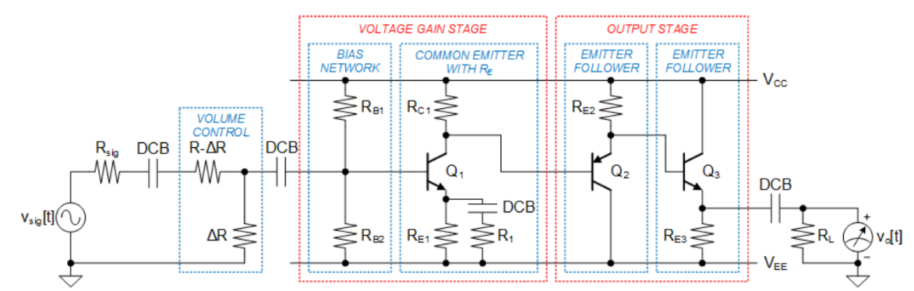

Figure 1. Audio amplifier consisting of five stages: (i) volume control, (ii) bias network, (iii) NPN common emitter amplifier with an emitter resistance, (iv) PNP emitter follower amplifier, and (v) NPN emitter follower amplifier.

|  |  |  |
| --- | --- | --- |
| **Design Constraint** | **Symbol** | **Nominal Value** |
| Operating Temperature | *T* | 300 K |
| Top-Rail DC Supply Voltage | *VCC* | +6 V |
| Bottom-Rail DC Supply Voltage | *VEE* | -6 V |
| Audio Signal Frequency | *fm* | 261.626 Hz |
| Signal Generator Output Resistance | *Rsig* | 50 Ω |
| Load Resistance | *RL* | 32 Ω |

Table 1. Design constraints

# Stages of amplifier design

## Volume Control Stage

The first stage we had to design was the volume control stage. In power amplifiers the volume control is an input sensitivity control. This will have no direct effect on the output stage of the amplifier, but rather determines how much resistance there is to the incoming input signal getting to the voltage gain stage. The purpose of regulating this input signal is to effectively turn the amplifier down. This is designed using a simple voltage divider that will be used for controlling the volume of the audio signal. The voltage divider was designed using a potentiometer, which would allow the sum of the two resistances to equal a chosen value of R.

(1)

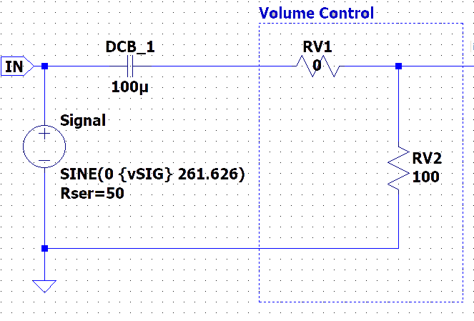  
Figure 2. Volume Control Stage

## Bias Tree Stage

A voltage divider biasing is commonly used in the design of a bipolar transistor amplifier circuits. Transistor Biasing is the process of setting a transistors DC operating voltage or current conditions to the correct level so that any AC input signal can be amplified correctly by the transistor. Establishing the correct operating point requires the selection of bias resistors and load resistors to provide the appropriate input current and collector voltage conditions. The biasing point operates on it being either “fully-ON” or “fully-Off” along its DC load line. This central operating point is called the “Quiescent Operating Point”, or Q-point. This method of biasing the transistor greatly reduces the effects of varying beta, (β) by holding the base bias at a constant steady voltage level allowing for best stability.

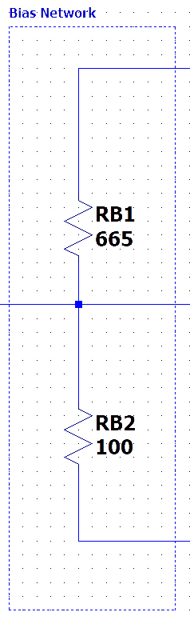

Figure 3. Bias Network Stage

## Common Emitter Stage

The common emitter amplifier is a three basic single stage bipolar junction transistor and is used a voltage amplifier. The base terminal will accept the input while the output is collected from the collector terminal. The emitter terminal is common for both the terminals. The base bias voltage is supplied from our bias tree network previously discussed. The Rc1 resistor is used at the output and is typically called the load resistance. The Re1 resistor is used for thermal stability, while DCB_3 capacitor (coupling capacitor) is used to separate the AC signals from the DC biasing voltage. The current gain of common emitter amplifier is defined as the ratio of change in collector current to the change is base current. The voltage gain is defined as the product of the current gain and the ratio of the output resistance of the collect to the input resistance of the base circuits.

(2)

(

The advantages of using a common emitter amplifier is as follows: low input impedance and it is an inverting amplifier, the output impedance of this amplifier is high, the amplifier has highest power gain when combined with medium voltage and current gain, the current gain of the common emitter amplifier is high.

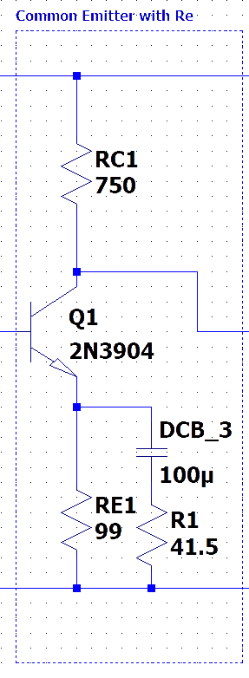

Figure 4. Common Emitter Stage

## PNP Emitter Follower Stage

The PNP common collector, or emitter follower, acts as a voltage buffer between the common emitter stage and the PNP emitter follower. It has a relatively high input impedance and a low output impedance. This allows a high voltage input and a high current output.

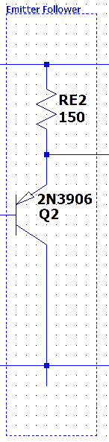

Figure 5. PNP Emitter Follower Stage

## NPN Emitter Follower Stage

Idk probably something like the PNP emitter follower?

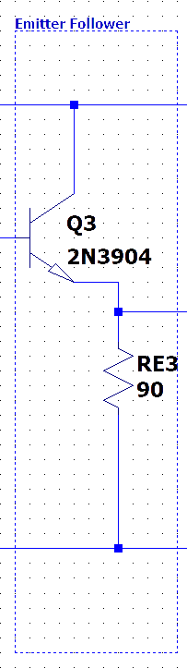

Figure 6. NPN Emitter Follower Stage

# Summary and Results

After design considerations were finalized, the circuit was simulated and analyzed to find certain figured of merit and confirm that the design operates within the specified design parameters. As shown in table 3, the quiescent power supply current, small-signal voltage gain deviation, and 1-dB output compression point are all within the required specifications.

|  |  |  |  |
| --- | --- | --- | --- |
| **Collector Current** | **Data Sheet Rating (mA)** | **Simulated Quiescent Value (mA)** | **Simulated Maximum Transient Value (mA)** |
| **Q1** | 200 | 8.60 | 11.3 |
| **Q2** | -200 | -36.6 | -49.8 |
| **Q3** | 200 | 62.8 | 139 |

Table 2. Absolute maximum transistor ratings for final design of audio amplifier

|  |  |  |  |  |
| --- | --- | --- | --- | --- |
|  | **Symbol** | **Requirement** | **Sim. Value** | **Unit** |
| **Quiescent Power Supply Current** | *Iq* | ≤ 200 | -124 | mA |
| **Small-Signal Voltage Gain Deviation** | *GD* | ≤ 0.1 | .00816 | dB |
| **1-dB Output Compression Point** | *V21dB* | ≥ 56.8 | 59.8 | dBmV RMS |

Table 3. Performance figures-of-merit (output parameters) for final design of audio amplifier

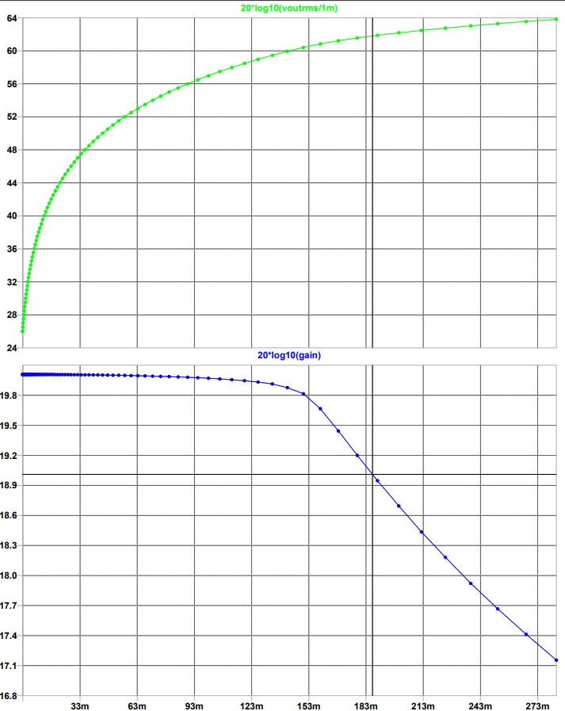

Figure 7. Gain vs Signal in mV

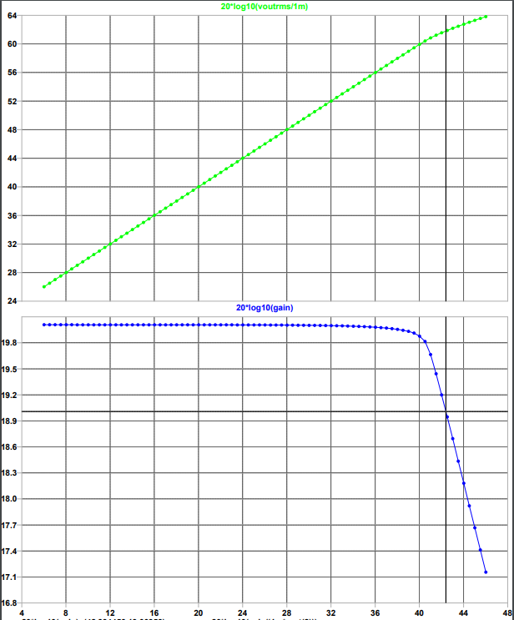

Figure 8. Gain vs Signal in dB

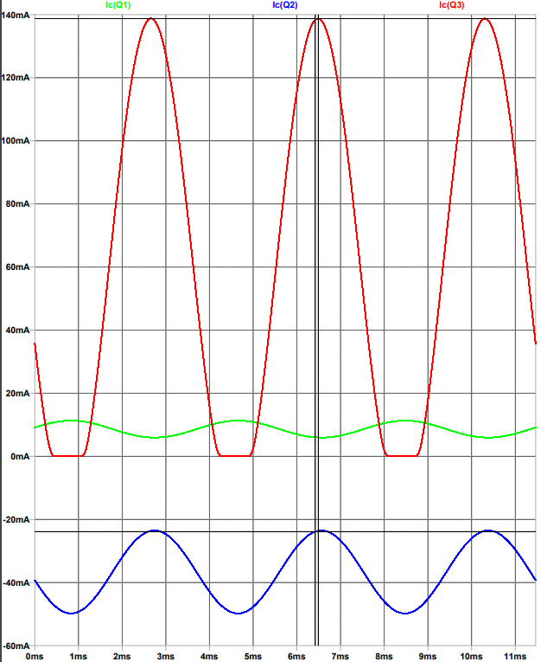

Figure 9. Collector Currents with 1dB Signal

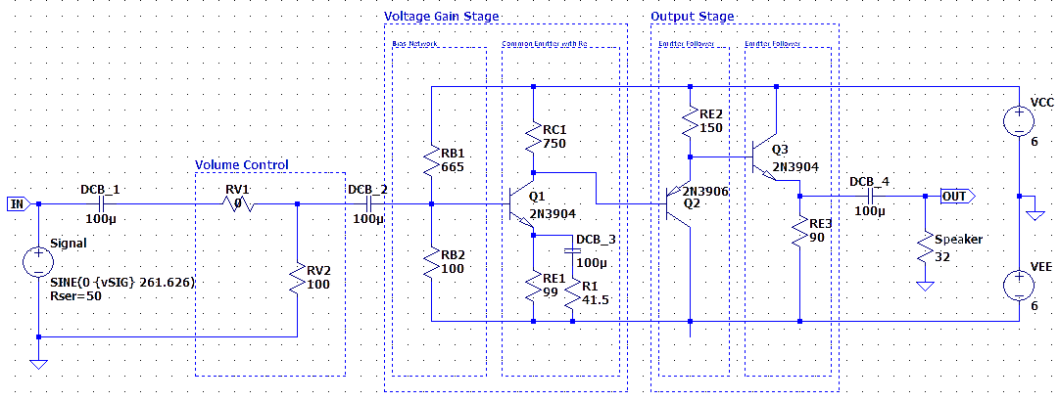

Figure 10. Finalized Audio Amplifier Circuit

References

[1] "Common Emitter Amplifier", *ElectronicsTutorials*. [Online]. Available: https://www.electronics- tutorials.ws/amplifier/amp_2.html. [Accessed: 07- Dec- 2019].

[2] "Common Emitter Amplifier Circuit Working and Characteristics", *ElProCus - Electronic Projects for Engineering Students*, 2019. [Online]. Available: https://www.elprocus.com/common-emitter-amplifier- circuit-working/. [Accessed: 07- Dec- 2019].

[3] "Power Amp Volume Controls – What do they really do?", *SweetWater*, 2007. [Online]. Available: https://www.sweetwater.com/sweetcare/articles/power- amp-volume-controls-what-really/. [Accessed: 07- Dec- 2019].

[4] A. Sedra, K. Smith, T. Carusone and V. Gaudet, *Microelectronic circuits*, 7th ed. New York: Oxford University Press, 2015.

[5] "Transistor Biasing", *ElectronicsTutorials*. [Online]. Available: https://www.electronics- tutorials.ws/amplifier/transistor-biasing.html. [Accessed : 07- Dec- 2019]

**Aaron D. Tobias** was born in Nashville, TN, USA in 1993. He is the youngest child of two South African immigrants. He is an alumnus of Ohio University and is currently pursuing a bachelor's degree in Computer Engineering at the University of Akron.

From 2016 to 2019, he was a Server at a local Mediterranean restaurant, Continental Cuisine. In the spring of 2020, he will be an Undergraduate Assistant for Digital Logic Design laboratory.

**Joshua R. Newman** was born in Jackson, MS, USA in 1988. He is a graduate of Hinds Community College and is currently pursuing a bachelor’s degree in Computer Engineering at the University of Akron.

From 2012-2016 he was in the U.S. Navy as a Weapons Equipment Technician onboard nuclear submarines. He is also member of the Boy Scouts of America Eagle Scout Society after earning his Eagle Scout award in 2006



**Jaret A. Varn** was born in Canton, OH, USA in 1998. He is a graduate of GlenOak high school and currently pursuing a bachelor’s degree in Computer Engineering at the University of Akron.

He will be starting his co-op rotation in the Spring of 2020 at Automated Packaging Systems – Sealed Air in Streetsboro, OH.